EXERCISE NO:5

DATE:14/10/2020

AIM:

To write a Python function to print missing characters to make string pangram.

a=input()

a=set(a.strip())

a.remove(chr(32))

b="qwertyuiopasdfghjklzxcvbnm"

b=set(b)

b=b.difference(a)

b=list(b)

b.sort()

print("".join(b))

LINK:

<http://103.53.53.18/mod/vpl/forms/edit.php?id=235&userid=1678>

OUTPUT:

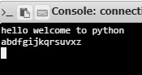

RESULT:

Hence, the Python function to print missing characters to make string pangram is printed.